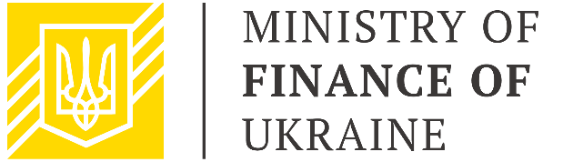

|  |  |
| --- | --- |
| **Public Finance Management**  **Sector Working Group**  September 22, 2020  16.00 – 17.30  Zoom | |
| **AGENDA** | |
|  |  |
| 16.00 – 16.10 | **Welcome address**  Mr. Denys Ulyutin, First Deputy Finance Minister of Ukraine, Chair  Mr. Xavier Camus, Head of Governance Section of the Delegation of the European Union to Ukraine, Co-Chair |
| 16.10 – 16.30 | **PFM Reform Priorities for 2021-2024**  Mr. Denys Ulyutin, First Deputy Finance Minister of Ukraine |
| 16.30 – 16.40 | **Streamlining the cooperation within PFM Sector Working Group**  Ms. Alina Chernomaz, PFM Coordinator for the Ministry of Finance, EU4PFM |
| 16.40 – 17.00 | **Comments and Q&A session** |
| 17.00 – 17.30 | **Conclusions and next steps**   * development of a schedule for finalization of draft PFM Strategy 2021-2024 in the thematic subgroups * updating the PFM priorities-donor support matrix |