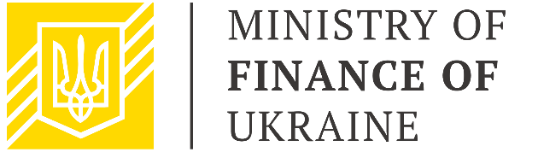

Public Finance Management
Sector Working Group

May 19, 2021
15.00 – 16.30
Zoom

AGENDA
15.00 – 15.10 | Welcome address  Mr. Denys Ulyutin, First Deputy Finance Minister of Ukraine, Chair  Mr. Xavier Camus, Head of Governance Section of the Delegation of the European Union to Ukraine, Co-Chair
15.10 – 15.50 | Discussion of the updated draft PFM Strategy for 2021-2025  Mr. Denys Ulyutin, First Deputy Finance Minister of Ukraine  SWG participants
15.50 – 16.10 | Overview of donor support to PFM Strategy implementation  Development partners
16.10 – 16.20 | Comments and Q&A session
16.20 – 16.30 | Conclusions and next steps

