Annex 1

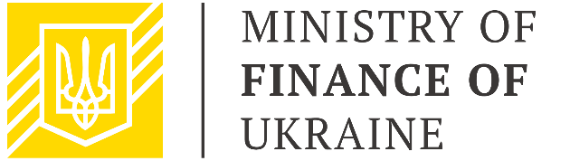

|  |  |
| --- | --- |
| **Public Finance Management**  **Sector Working Group**  February 15, 2022  15.00 – 16.30  Zoom | |
| **AGENDA** | |
|  |  |
| 15.00 – 15.10 | **Welcome address**  *Mr. Denys Ulyutin, First Deputy Finance Minister of Ukraine, Chair*  *Mr. Xavier Camus, Head of Governance Section of the Delegation of the European Union to Ukraine, Co-Chair* |
| 15.10 – 15.30 | **Presentation of priority tasks of the PFM Reform Strategy for 2022**  *Mr. Denys Ulyutin, First Deputy Finance Minister of Ukraine, Chair*  *SWG Participants* |
| 15.30 – 15.45 | **Presentation of passports of indicators for monitoring the implementation of the PFM Reform Strategy**  *SIGMA Representative* |
| 15.45 – 16.20 | **Discussion of support for the implementation of the Plan of Activities and Priorities for 2022 by Development Partners**  *Mr. Xavier Camus, Head of Governance Section of the Delegation of the European Union to Ukraine, Co-Chair*  *Development Partners* |
| 16.20 – 16.30 | **Conclusions and next steps** |